Matthew Kavanagh

Lab 5 Report

Screenshots

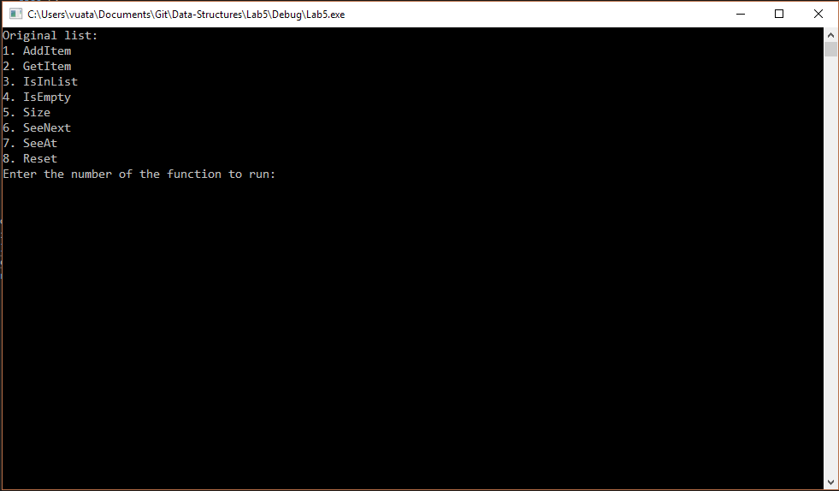

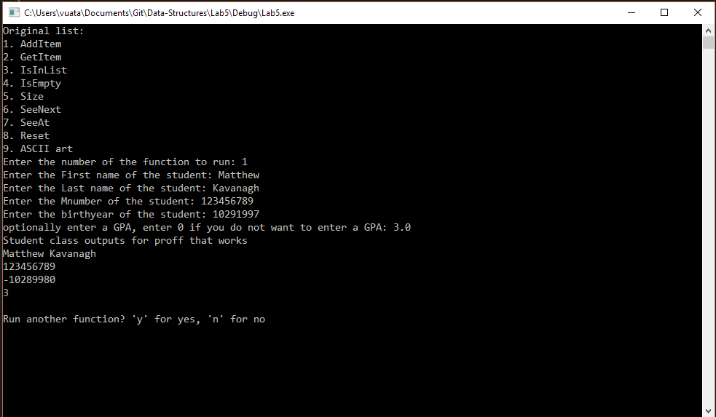

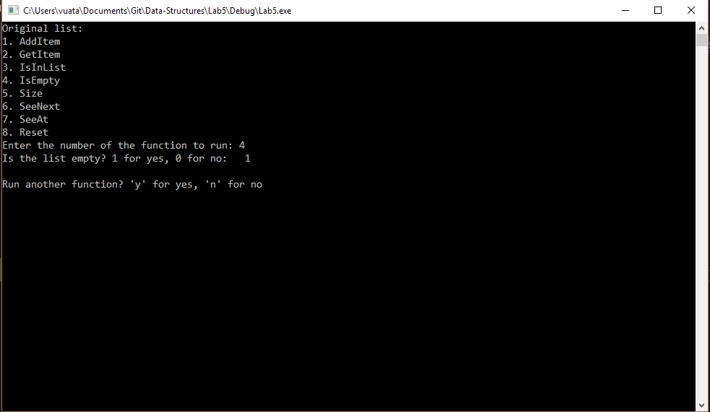

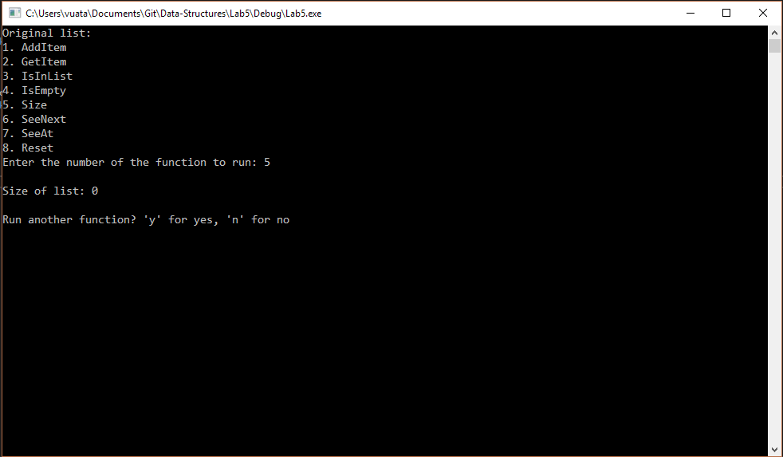

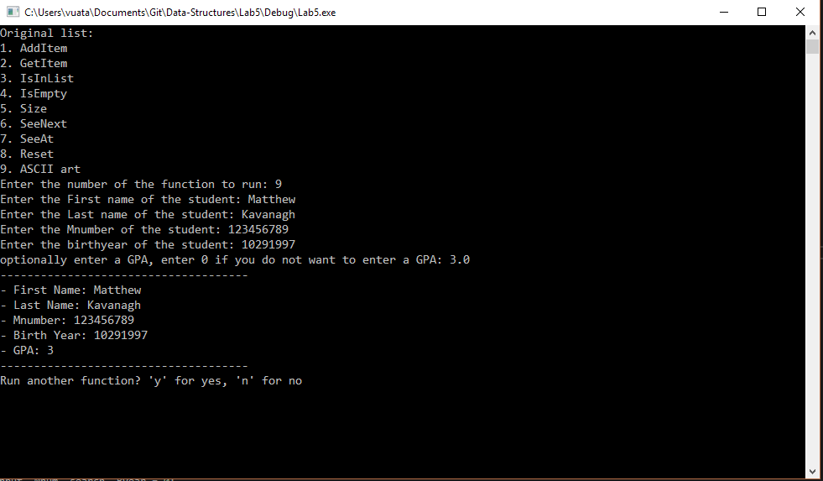

Full honesty here only a few things work as expected. The list that I create is not transferring over to the student class and I have no idea how. Therefore, many functions may well work if something was changed but since the items are not being passed over to so they don’t work as expected and I don’t really know how to fix it.

Compiled and tested on Visual Studio 2017